NOTE: THIS PRESS RELEASE DRAFT SERVES AS A TEMPLATE ONLY. PLEASE DO NOT DISTRIBUTE A PRESS RELEASE UNTIL ONE IS APPROVED BY THE DAILY MILE.
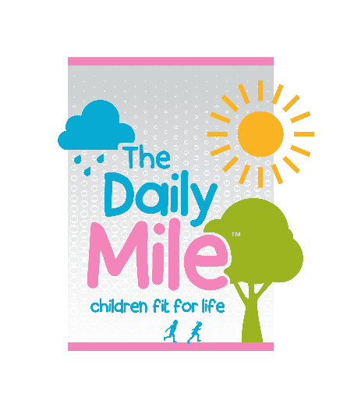
CONTACT INFORMATION
The Daily Mile USA
William Russell, Program Manager
williamrussell@thedailymile.us
RELEASE DATE:
Thursday, April 29, 2021

STRATEGIC PARTNERSHIP: The Daily Mile and COMPANY aim to
promote childhood health and wellbeing

(City, State) – During these unprecedented times, more and more children are in need of programs that improve their overall health and wellbeing. Today, COMPANY announced its partnership with The Daily Mile, a nonprofit dedicated to promoting physical, emotional, and social health for young children.
According to the CDC, one in five children experience a mental disorder in any given year. Children with mental disorders can experience problems both at home and at school. Childhood obesity is also a severe issue. Unhealthy children are at risk for cardiovascular disease, diabetes, breathing problems, and other serious health complications.
COMPANY and The Daily Mile are joining forces to tackle these issues surrounding childhood health.
Please provide a quote from your organization’s leadership team/member about why s/he decided to collaborate with The Daily Mile.
Please describe what concrete actions will result from this partnership. Refer to Letter of Intent.
The Daily Mile is a free, fully inclusive program open to all schools. It is designed to get kids moving for an additional 15 minutes during the school day. This physical activity, which is in addition to PE, has had a substantial and positive impact on both students and teachers throughout the country.
“The Daily Mile is a profoundly simple concept, yet has been proven incredibly effective,” said Daily Mile Program Manager Bill Russell. “Children enjoy the social interaction, seeing it as a natural part of their day. Teachers benefit from the improved concentration and behavior in class without the strain of any additional training, cost, or equipment. Parents appreciate the mental and physical benefits it brings to their children. Everyone wins!”
Former elementary school principal and Founder of The Daily Mile Elaine Wyllie started the program in 2012 after she become increasingly concerned about the lack of fitness in her students. “After four weeks, The Daily Mile produces transformational change. Children become more physically fit, focused in the classroom, confident, and resilient,” said Wyllie.

For more information, please visit thedailymile.us or contact Bill Russell at williamrussell@thedailymile.us
###

